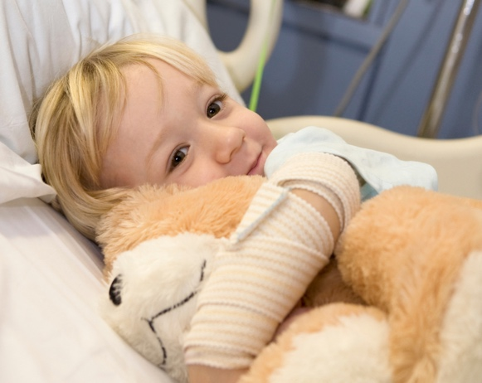

Dear Senator or Representative XXX,
Our son, Sebastian, was diagnosed with Neurofibromatosis when he was just nine months old. As a new mother, learning that my child had a progressive genetic disease was overwhelming and frightening. After extensive testing with genetic specialists, the diagnosis was confirmed. Accepting that our son faces a lifelong, often disfiguring and sometimes life-threatening condition changed our family forever and motivated us to fight for better treatments and a cure.
Despite the patient advocates efforts, private fundraising alone is not enough. Strong federal investment in research is critical to advance research, improve treatments, and bring hope to the thousands of Americans living with Neurofibromatosis. Federally funded research can change the trajectory of this disease for children like Sebastian.
We respectfully request your support for $25 million in FY 2027 for the Neurofibromatosis Research Program through the Congressionally Directed Medical Research Programs (CDMRP) and support for language encouraging investment in NF research at the National Institutes of Health (NIH). This investment would provide meaningful progress toward improved outcomes, better quality of life, and ultimately a cure.
Thank you for your time, consideration, and commitment to families affected by Neurofibromatosis.
Kindest regards,
NF Advocates Name XXX
Address: 125 Main Street
City, State zip code
email

